2023
September
Regional Meetings:
12 St. Charles
13 Jefferson City
14 Springfield
15 Kansas City
30 District VP Officer Candidates
Application due to District Leaders

October
6 Final FLC Registration Due

13-16 DECA AMPED + MBA Research Conclave

29-30 Fall Leadership Conference,
Lake of the Ozarks, Tan-Tar-A

November
8 District Advisors/CED Meeting/District DVP Training 10:00-4:00 Jefferson City

15 Deadline: Initial Online DECA Membership Roster DUE

13-19 Global Entrepreneurship Week

17-19 The Ultimate DECA Power Trip
Austin, Texas

December
4 Mizzou AdZou Marketing Challenge

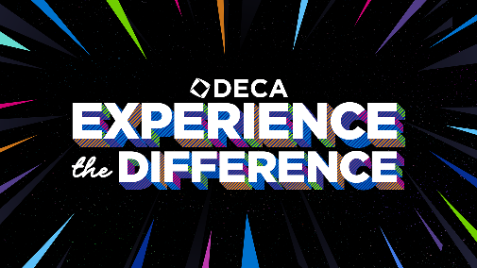

2024

January
6 State Career Development Conference Planning KC. MO.

11 SBE Document Due

13 CED Training & DECA Board Meeting Jefferson City

31-4 Sports & Entertainment Marketing Conference,
Orlando FL

February
Varies District Conferences
1 Missouri DECA Scholarships due

14 Legislative Day, Jefferson City

16 Registration Deadline for SCDC

16 SCDC Written Events need to be Uploaded to DLG

March
3-5 State Career Development
Conference
Crown Center, Kansas City

April
26-1 ICDC Anaheim, California

May
? Excellence in Marketing Education Reception,
Jefferson City

